AI Assignment 3
Neeti Kurulkar
Greedy Algorithms

- Prim’s Algorithm for Minimal Spanning Tree

Code:

class Graph:
def __init__(self, v):
self.v = v
self.adj_mat = [[0 for _ in range(v)] for _ in range(v)]

def add_edge(self, a, b, w):
self.adj_mat[a][b] = w
self.adj_mat[b][a] = w

def prim_mst(self, start):
visited = [False] * self.v
visited[start] = True
print("\nEdge : Weight")

edge_count = 0
while edge_count < self.v - 1:
minimum = float('inf')
x, y = -1, -1

for i in range(self.v):
if visited[i]:
for j in range(self.v):
if not visited[j] and self.adj_mat[i][j] != 0:
if minimum > self.adj_mat[i][j]:
minimum = self.adj_mat[i][j]
x, y = i, j

print(f"{x}-{y}: {minimum}")
visited[y] = True
edge_count += 1

n = int(input("Enter number of vertices: "))
g = Graph(n)
e = int(input("Enter number of edges: "))

print("Enter edges (u v w):")
for _ in range(e):
u, v, w = map(int, input().split())
g.add_edge(u, v, w)

start = int(input("\nEnter starting vertex for MST: "))
g.prim_mst(start)

Output:

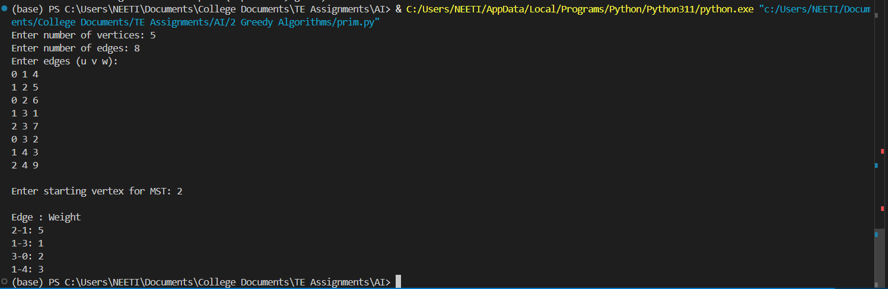

- Selection Sort Algorithm

Code:

def get_input():
n = int(input("Enter the number of elements in the array: "))
arr = []
for i in range(n):
element = int(input(f"Enter element {i+1}: "))
arr.append(element)
return arr

def selection_sort(arr):
"""Selection Sort Algorithm"""
for i in range(len(arr)):
min_idx = i
for j in range(i + 1, len(arr)):
if arr[j] < arr[min_idx]:
min_idx = j

arr[i], arr[min_idx] = arr[min_idx], arr[i]

arr = get_input()

print("Original array:", arr)
selection_sort(arr)
print("Sorted array:", arr)

Output:

